|  |  |
| --- | --- |
| NAME | G.Avin |
| ZONE | 8 |
| TEAM ID | NM2023TMID00426 |
| COLLEGE NAME | Ganesh college of Engineering |

# 1.Go to the chrome and open remix platform

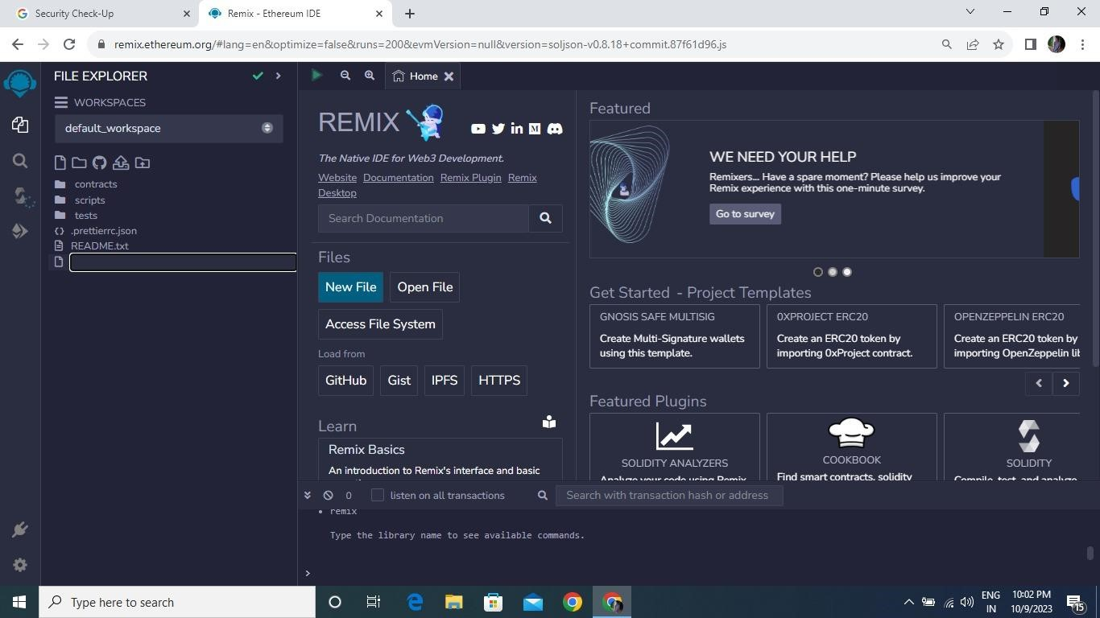

# Open the remix page and create a new file

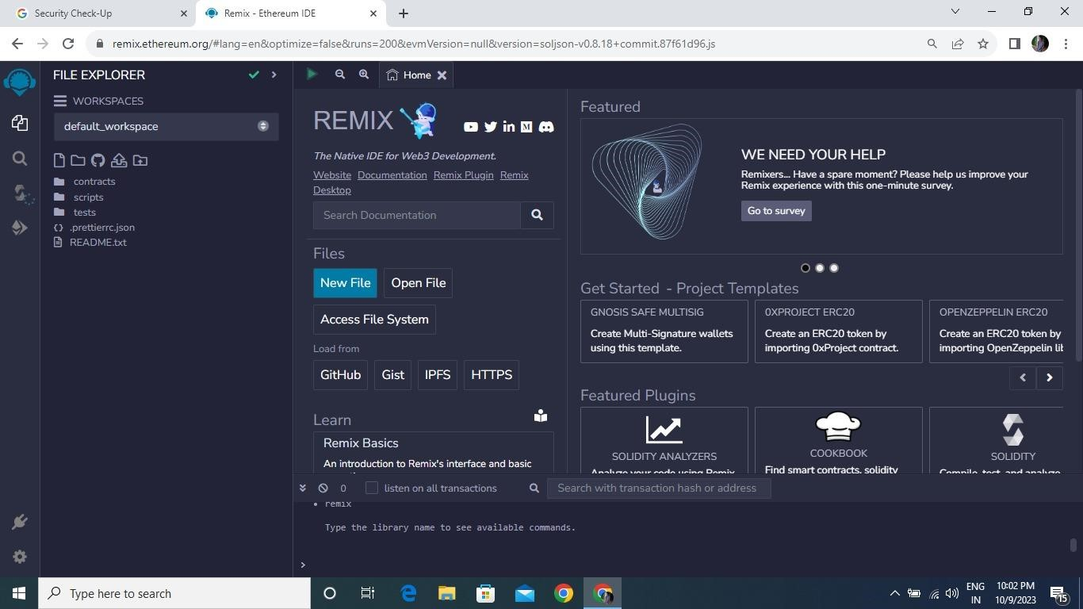

# In that newly created file, create a program to return your string, "Zone name"

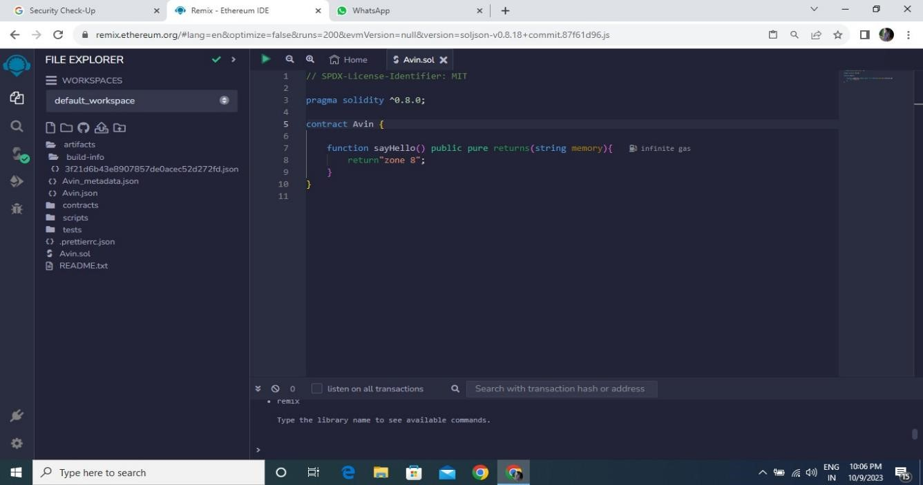

# Save the program and compile it to get the ABI and Bytecode

ABI:

[

{

"inputs": [],

"name": "sayHello",

"outputs": [

{

"internalType": "string",

"name": "",

"type": "string"

}

],

"stateMutability": "pure",

"type": "function"

}

]

Bytecode:

608060405234801561001057600080fd5b50610173806100206000396000f3fe

608060405234801561001057600080fd5b506004361061002b5760003560e01c

8063ef5fb05b14610030575b600080fd5b61003861004e565b60405161004591

9061011b565b60405180910390f35b6060604051806040016040528060068152

6020017f7a6f6e65203800000000000000000000000000000000000000000000 00000000815250905090565b600081519050919050565b60008282526020820 1905092915050565b60005b838110156100c557808201518184015260208101

90506100aa565b60008484015250505050565b6000601f19601f830116905091

9050565b60006100ed8261008b565b6100f78185610096565b9350610107818

5602086016100a7565b610110816100d1565b840191505092915050565b6000 602082019050818103600083015261013581846100e2565b90509291505056fe a26469706673582212205e0cb7a8223c51cc63a0d7887ee4d1482d7619e4b13 de63bca1a4259b7e9e6cc64736f6c63430008120033

# Finally Deploy it to display the output

